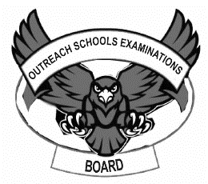**OUTREACH SCHOOLS EXAMINATION BOARD**

**MIDTERM II EXAMINATION 2023**

**Age Group (3 – 4 years): BABY CLASS**

**Learning Area 5: Reading**

My name is __________________________________________

1. **Read and act these sounds.**

a b c e f i

j m n p r s

t v

**Shade for sound ‘s’**

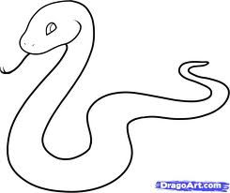

1. **Match and write.**

f v _____________

m c ____________

v o ____________

c f _____________

o m ___________

1. **Match pictures to sounds.**

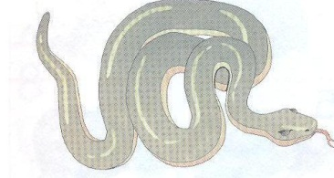 t

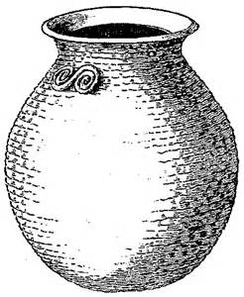 a

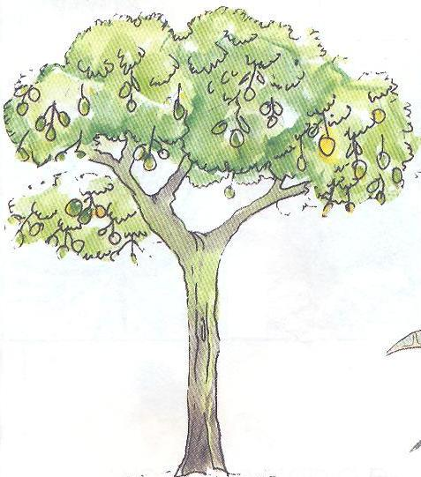 s

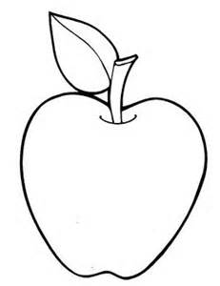 p

1. **Circle the odd man out.**

n m n

i i h

s r r

f b f

1. **Copy these sounds.**

|  |  |  |  |  |
| --- | --- | --- | --- | --- |
| f | c | t | a | i |
|  |  |  |  |  |

**End**